**Working with Bar Chat and Generating PDF From Views in ASP.NET Core MVC**

Generating PDFs from MVC views is useful when you want to provide users with a downloadable and printable version of a webpage or report. PDFs are a widely accepted format for sharing documents and reports across different platforms while maintaining the layout and design.

So, in simple words, generating a PDF from an MVC view is useful whenever you need a snapshot of data in a presentable, standardized format especially for things like invoices, receipts, sales reports, etc. For example, generating a PDF sales report allows business users to archive, print, or share the report without relying on the web interface.

**Real-time Application to Generate PDF from MVC Views:**

We will develop is an E-commerce Sales Reporting App. Its core functionalities include:

* **Data Display:** It fetches orders, customers, products, and order items from the SQL Server database using Entity Framework Core.
* **Filtering & Pagination:** Users can filter sales data based on date ranges, product categories, and order statuses. The results are paginated to improve usability.
* **Data Visualization:** The app displays a summary and a day-wise stacked bar chart with an overlaid line chart for total sales.
* **PDF Export:** It offers an option to export the sales report as a PDF, making it convenient for sharing and offline usage.
* **AJAX Modal:** A modal dialog is used to show the details of order products dynamically using AJAX, enhancing the user experience.

Now, let us understand the flow from web pages point of view:

**Search Filter:**

Enables users to refine the sales data by selecting a date range, product category, and order status, ensuring the displayed report focuses only on relevant orders.

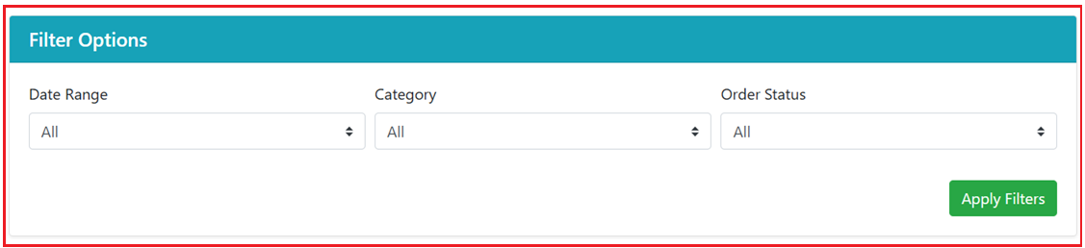

**Summary and Chart:**

Presents overall metrics—total orders, pending, completed, canceled, and total sales and visualizes daily order counts alongside sales trends through a stacked bar chart and line graph.

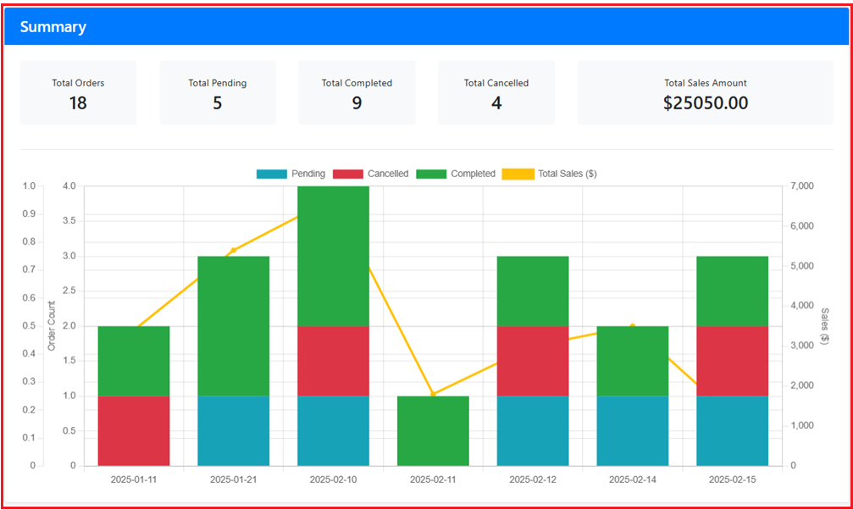

**Order Details:**

Lists filtered orders in a paginated table, showing key information such as order number, date, status, and total amount, with a quick option to export the report to PDF.

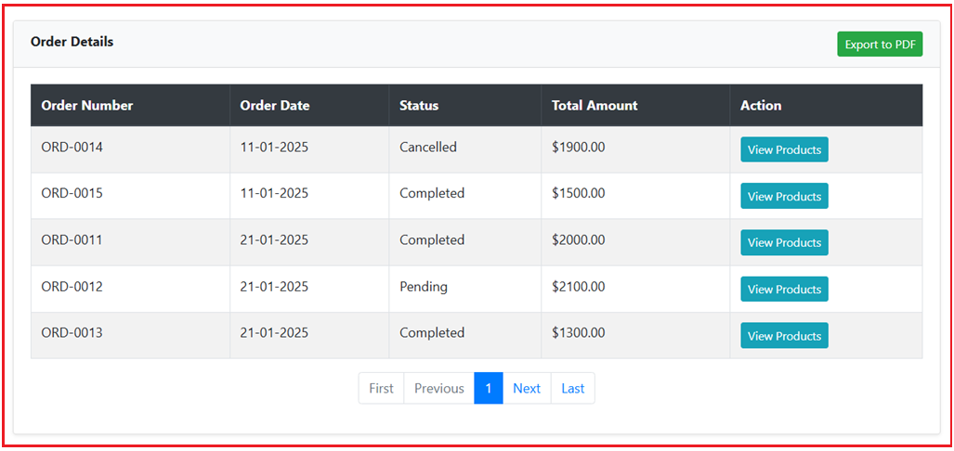

**View Products Modal:**

Shows a modal pop-up with product-level details for a selected order, including quantity, unit price, and line total, without navigating away from the main report.

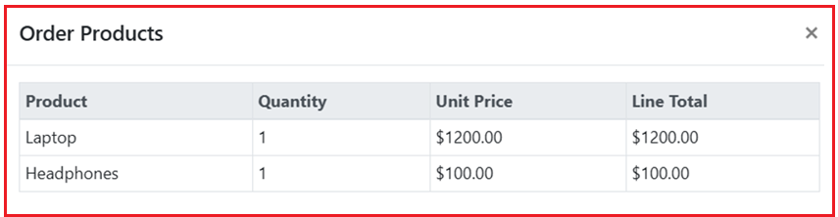

**Export to PDF:**

When you click on the Export to PDF button, it will download the PDF as shown in the below image.

